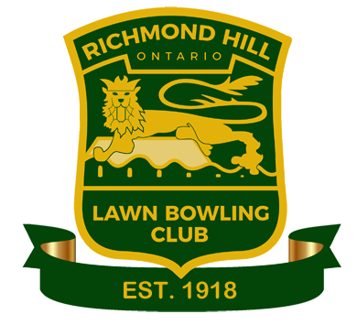 | RICHMOND HILL  LAWN BOWLING CLUB  Youth Registration Form  (for players 12 to 18 years of age)
Name: |  |  |  | Age on May 1:
Address:
 |  |  |  | Postal Code:
Phone #: |  |  | Email:
I give permission to share my phone # and email address with RHLBC members. |  |  |  | Yes ☐ No ☐
Gender: F ☐ M ☐ |  |  | Signature:
Parent or Guardian Contact Information:
Name:
Address: same as above ☐ - or -
 |  |  |  | Postal Code:
Phone #: |  |  | Email:
Parent or Guardian Consent: I hereby agree that my daughter/son/ward, named above, has my permission to participate in lawn bowling and other club activities at the Richmond Hill Lawn Bowling Club.

Parent or Guardian’s Signature:
Membership Fee – includes free use of club bowls for the first season
☐ Special Offer – 3 Lessons (includes unlimited bowling in June) |  |  |  |  | $20.00
☐ Membership after Special Offer (excludes $35 OLBA Fee) |  |  |  |  | $30.00
☐ Membership without Special Offer (excludes $35 OLBA Fee) |  |  |  |  | $50.00
Payment Amount: |  | Cash ☐ Cheque ☐ # |  |  | $
Payment received by:
A Release of Liability Waiver Form must be signed before playing. If the Youth Bowler is under 18 years of age, a Parent or Guardian must sign it.

